**Motivation**

Race has played an integral part in the founding of America. Since the first pilgrims settled in the Americas, chattel slavery and the abduction of untold African souls to this continent have plagued the. It seems that the legacy of slavery, Jim crow and the civil rights movement still hold sway, as calls for prison reform, social justice and police brutality have been on the forefront of the American consciousness. Yet much of the above can be thought of as just anecdotal evidence foisted upon the populace by shoddy thinking and an unanalytical gaze. How much of the sentiment that race plays an integral factor in Americas criminal justice system, can be justified by the scientific method of inquiry available to us by data scientific methods.

**Dataset Description**

A dataset of police shootings in 2015 was used to assess whether African Americans were more likely to be shot and killed by police. The Washington Post is compiling a database of every fatal shooting in the United States by a police officer in the line of duty since January 1, 2015.

In 2015, The Post began tracking more than a dozen details about each killing — including the race of the deceased, the circumstances of the shooting, whether the person was armed and whether the victim was experiencing a mental-health crisis — by culling local news reports, law enforcement websites and social media and by monitoring independent databases such as Killed by Police and Fatal Encounters.

The Post is documenting only those shootings in which a police officer, in the line of duty, shot and killed a civilian — the circumstances that most closely parallel the 2014 killing of Michael Brown in Ferguson, Missouri, which began the protest movement culminating in Black Lives Matter and an increased focus on police accountability nationwide. The Post is not tracking deaths of people in police custody, fatal shootings by off-duty officers or non-shooting deaths.

The FBI and the Centers for Disease Control and Prevention log fatal shootings by police, but officials acknowledge that their data is incomplete. In 2015, The Post documented more than two times more fatal shootings by police than had been recorded by the FBI.

**Exploratory Analysis**

The experimental hypothesis is that police nationwide have implicit bias when it comes to blacks and are more likely to shoot, harm and otherwise abuse African Americans in situations where Whites would be more likely to survive their encounter unharmed. In order to have support for this hypothesis and examination of police shootings from 2015-2017 will be examined in a framework that will highlight any differences between shootings of African Americans.

To begin we must first understand the total population of the United States separated by race. A cursory analysis of the data shows the following percentages

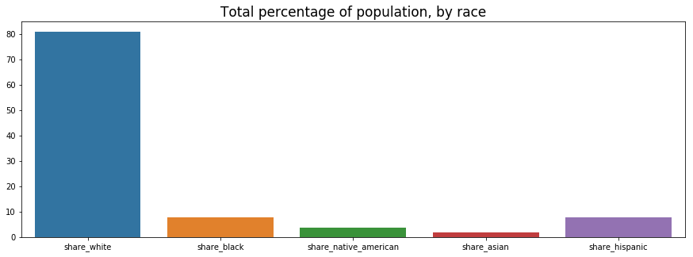

It is evident that whites comprise a majority of the population according to the shared by race database provided in this study. It is important to note that since the race of the country is primarily comprised of whites, the expectation is that they will be over represented in police shooting is one does a raw count of the number of shootings by race. The below shows the count of shootings based on race.

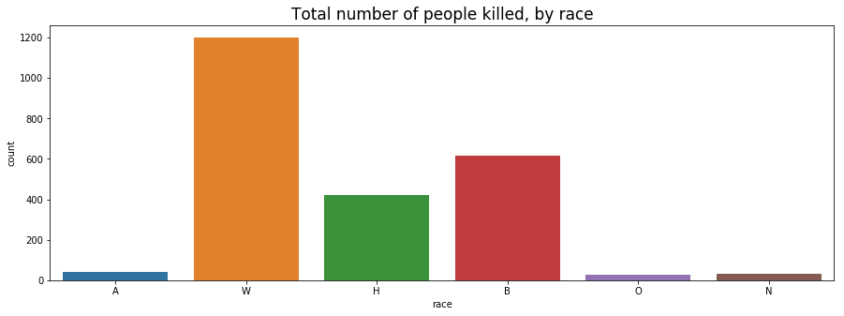

This seems to hold with whites comprising the greatest number of victims. However if we examine the proportion of races shot relative their number in the population we get a different picture.

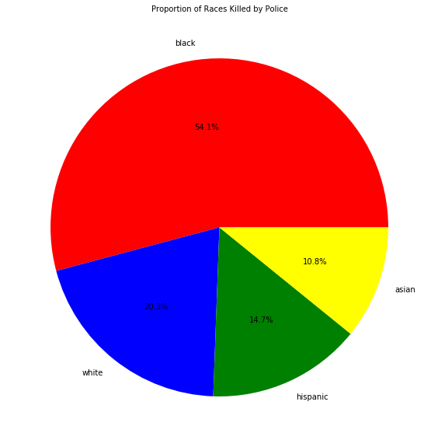

As seen above the proportion of blacks killed by police is significantly bigger than the other races in this dataset. Another important descriptive statistic would be to look at how the killings vary by state. From this we can determine which states are more likely to pose a increased risk to blacks in the population. The following graph shows this distribution

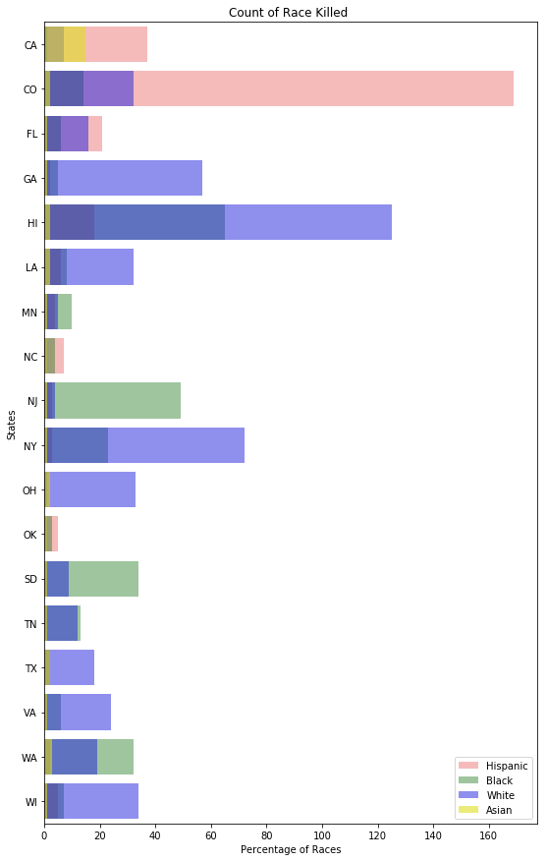

As we have seen this plot is deceptive because it does not show how these populations of races are represented within the entire population of the united states. If we examine the proportion of shootings with regard to race and state we get the following

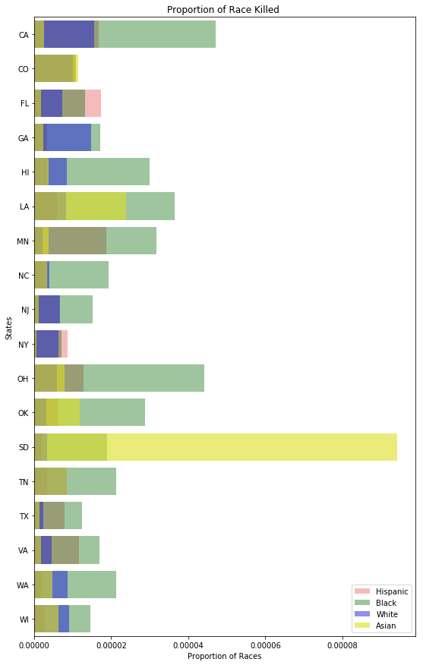

As can be seen from above the blacks in many states are shot at a higher rate than other races barring NY and SD. This bodes well for the hypothesis that stereotype bias has a part to play in shootings. It is possible that because of their high representations of the population in NY and low population representation in SD that either a) there are a high number of police officers of color in NY and b) There are not enough or high representation of blacks in SD. Further research and data are needed to validate these claims.

Finally to bolster the claim that race plays a significant part in determining who is shot by police and A/B test was performed to determine if there were significant differences in being killed by police when it came to armed and unarmed suspects. The t-test makes a comparison of armed vs unarmed victims relative to race. The test also segments the data by race. So the distribution of armed and unarmed are made with respect to the entire population. The race under question is assigned a value of 1 and 0 otherwise. The two populations are then separated by armed or unarmed victims. The t-values reveal that for blacks and Hispanics there is no significant difference in mean number of deaths for armed and unarmed victims. While the other races show that there is a statistically significant difference between being shot while armed or unarmed. The p-values for the A/B tests are given below

|  |  |
| --- | --- |
| Black | 0.26504814592776615 |
| White | 2.102910619410183e-05 |
| Hispanic | 0.5310346217081071 |
| Asian | 9.947146784541988e-17 |
| Native | 1.4373617790239859e-08 |

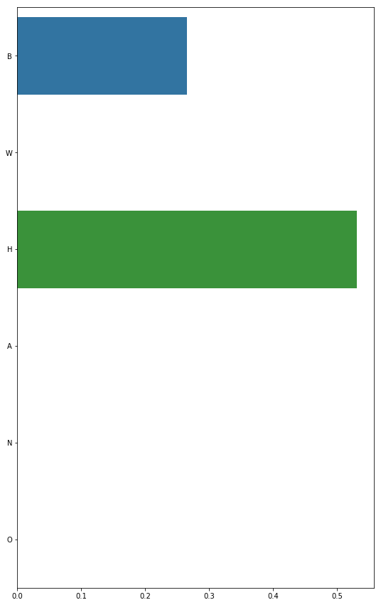

There seems to be significant evidence to suggest that the hypothesis of racial bias is tenable. To summarize the findings. Blacks are more likely to be shot and killed by the police based on their proportional representation in the population. Statewide blacks are shot and killed by the police proportionately more than other races. Finally there is no statistically significant difference between being shot while armed or unarmed for Hispanic or black citizens.

**Experimental Design**

With the proliferation of video games it has become easier to simulate real life contexts and to measure the responses of participants. The proposed experiment for testing police bias involves simulating black and white characters in the same context holding a gun or some other inanimate object. The participant would then decide whether that person poses a threat by pressing a video game controller button. The response times of the participants would then be measured along with threat choice can be recorder. The measurement of both these parameters could determine if there is a statistically significant difference between the two races when it comes to a shoot decision. For instance it may be found that black characters who held an inanimate object were more likely to receive a shoot decision from participants than for whites.

The experiment is designed to recruit 1000 police force participants using a randomized stratified sample based on state. Within each state a randomized stratified sample of 20 participants would be chosen from statewide police departments. An initial state would be chosen to show proof of concept as preliminary data would be obtained and analyzed to provide information on any refinements that would be needed.

Experiments would be performed in each police department by having an experimenter greet participants in groups of 1 to 4 and have them introduce the study. Participants would learn about the rules of the game. Participants would then move to computer terminals in a private room and play the video game. Once the game was over the experimenter will announce the end of the timed game trial.

Successful completion of the experiment will mean that all participant data for all stratified samples were successfully collected.

If data collected from the experiment indicate that there is a statistically significant difference between racial groups perhaps a followup with designing programs that address racial bias are necessary.